May 29th, 2011
Hi
Not much to write about. The aircraft carrier USS Carl Vinson arrived in HK last Sunday. The captain, inevitably, was quizzed on its role in the burying of bin Laden, but he was saying nothing. Also, last Sunday, South Africa won the London 7s. Fiji beat NZ in the semi-finals but that was not enough to stop NZ clinching the overall title, their 9th in 12 years. This weekend, the last round of the 7s is being held in Edinburgh but the fight is between Fiji and England for the overall second place.
In HK, the government is in trouble again. This time it is for (alleged) interference in the selection of a group to offer computer services to children. Although the selection process was supposed to be independent, someone high up in the government told the group doing the selection to choose the pro-government / pro-Beijing tender, even though it was not the best. It is said that the order came from someone higher than the Financial Secretary (FS), which means it was either the Chief Executive himself or his deputy, as these are the only people higher than the FS.
Very high levels of air pollution again in HK. Right now, the index in parts of HK Island has reached 190 which is a dangerous level.
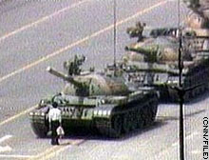
Next Saturday is the anniversary of the June 4th 1989 massacre in Beijing. There will be the annual candlelight vigil in HK, which is the only city in China to commemorate the event.
The material below was in last year's letter. But as it may still be interesting, I will leave them in.
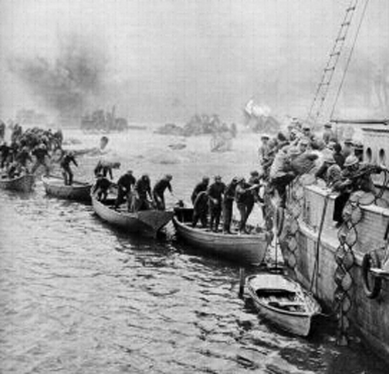
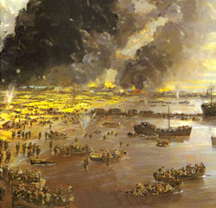
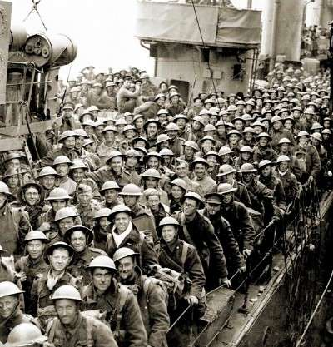
Some interesting news items from the past week. First, research in the UK suggests that brushing teeth less than twice a day increases the risk of heart attacks and strokes. Something to do with bacteria from the mouth getting into the blood and somehow causing damage elsewhere. Then there was the 70th anniversary of the Dunkirk evacuation in 1940 when lots of little boats sailed from England across the channel to France to rescue about 340 000 troops stranded on the beaches who had been driven back to the sea in France by the Germans, and ferried them to larger vessels off-shore. I suppose you know the story. To commemorate the rescue, many of the actual boats that helped in the rescue sailed across to France again. It was after this rescue that Churchill gave his famous defiant speech “We shall fight on the beaches ….” If you want to listen to it, go to this website:
http://news.bbc.co.uk/onthisday/hi/dates/stories/june/4/newsid_3500000/3500865.stm
Or, more directly:
http://www.bbc.co.uk/mediaselector/check/player/nol/newsid_6570000/newsid_6571500?redirect=6571515.stm&bbwm=1&bbram=1&nbwm=1&nbram=1&news=1
Another health issue I learnt about this past week regards sunscreens. It turns out that many of them not only provide little protection but may increase the risk of cancers. All the sunscreens available in the US have been evaluated and of the 500 sports/sunbathing sunscreens, only 39 (~8%) are regarded as safe. Similar products in Europe are a little better as they are allowed to include chemicals that are not yet in use in the US. Look at the websites below. The second website lists every sunscreen on the market with details about them.
http://www.aolnews.com/health/article/study-many-sunscreens-may-be-accelerating-cancer/19488158
http://www.ewg.org/2010sunscreen/best-beach-sport-sunscreens/
That seems to be it for now.
Cheers

